✴

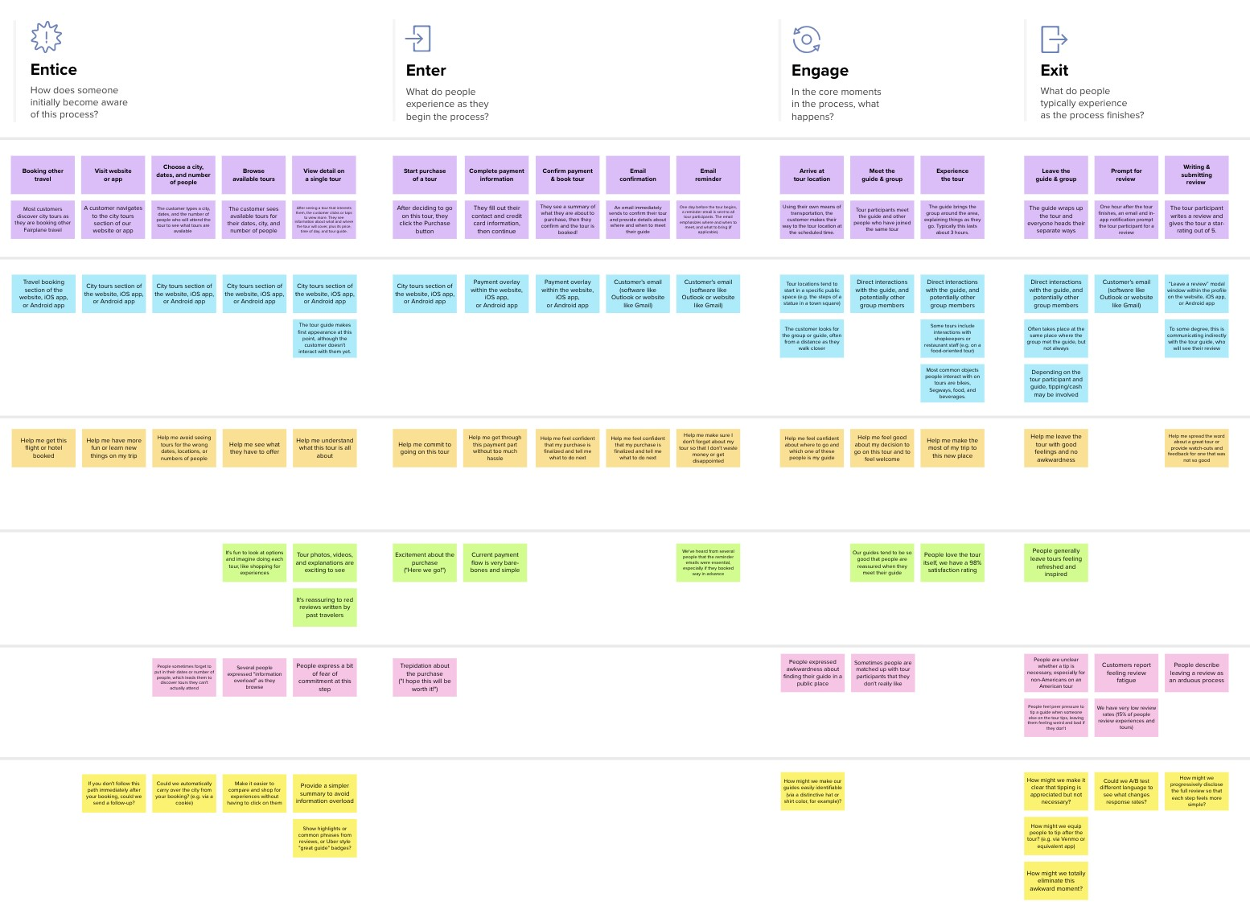

**Template**

**Document an existing experience**

**TIP**

As you add steps to the experience, move each these “Five Es” the left or right depending on the scenario you are documenting.

Narrow your focus to a specific scenario or process within an existing product or service. In the **Steps** row, document the step-by-step process someone typically experiences, then add detail to each of the other rows.

**Signup/Logi**

**Signup/Login**

**n**

Customer experience journey map

|  |  |  |  |  |  |
| --- | --- | --- | --- | --- | --- |
| **SCENARIO**  **Browsing, booking, attending, and rating a local city tour** | **Entice**  How does someone initially become aware of this process? | **Enter**  What do people experience as they begin the process? | **Engage**  In the core moments in the process, what happens? | **Exit**  What do people typically experience  as the process finishes? | **Extend**  What happens after the experience is over? |
| **Steps**  What does the person (or group) typically experience? | **Online Web browsing/**  **advertisements/Social**  **media/Hear from Research on**  **friends website**  **Comparing Asking other users'**  **available solutions experience** | **Signup/Login**  **Research about website** | **Upload hand-drawn Analyze the result sample of spirals provided by the**  **and waves application**  **Go through the suggested treatment** | **Have clarity about Have a prediction if the disease the patient has**  **Parkinson's**  **Have idea regarding the treatment procedure** | **Visits doctor and Shares his**  **rechecks the result experience**  **Gives feedback** |
| **Interactions**  What interactions do they have at each step along the way?  **People:** Who do they see or talk to?  **Places:** Where are they?  **Things:** What digital touchpoints or physical objects would they use? | **Online Interactions Discuss about the Discuss with friends**  **with websites/ about the**  **advertisements available options trustworthiness of**  **/social media with friends. this application.**  **Discuss about the pros and cons with other users of the app.** | **Take help from past Compares available users to understand options by visiting the website. website and asking users of other apps.** | **Interact with app as Take help from other**  **users to understand the**  **per the details type of samples**  **required required for prediction.** | **Interacts with other potential users about the user friendly interface of the app.** | **Discuss the results Users interact with Spread the word in with a doctor. the app for further the area about the**  **treatment application.** |
| **Goals & motivations**  At each step, what is a person’s primary goal or motivation? (“Help me...” or “Help me avoid...”) | To get a solution for To look for an To look for an early detection of alternative solution app that is data Parkinson's disease other than already driven and  existing solutions. predicts  accurately. | Understand Know about  the user the  interface of prerequisites  the for prediction.  application. | To get an To To get an  accurate understand understanding  prediction if the of treatment  patient has more about options  Parkinson's the disease. available.  disease. | Detailed analysis  Decide about the of available and  next steps suitable  according to the treatment  prediction by options  application. | Let other Get a Decide on  needful people confirmation treatment  know about the about the options to  application disease. be taken |
| **Positive moments**  What steps does a typical person find enjoyable, productive, fun, motivating, delightful, or exciting? | Knowing that early  detection of disease Finding about an online  is possible application that uses Realization that the application  latest technology to uses standards defined by  predict the disease. Movement Disorder Society Unified Parkinson's rating scale to  assess the severity of disease. | Transparency on methods and data used for prediction.  Easy to undestand Detailed information  user interface. about the disease.  High accuracy of the application as compared to other available options. | Easy procedure to No complex  get the prediction prerequisites for  about the disease. taking samples from patients. | Accurate prediction Transparency about  of the disease. severity of disease.  Guidance about treatment procedure. | A pre-understanding More than one  of disease before choice about App easily visiting the doctor. treatment options accessible on  available. internet for anyone  to use. |
| **Negative moments**  What steps does a typical person find frustrating, confusing, angering, costly, or time-consuming? | Skeptical about the  accuracy and Overwhelmed by  trustworthiness of many options  the app. available on internet. | Very less to no pre- Not comfortable with  understanding of using mobile phones or  other technological  disease. aspects of the app. | Unstable internet No easy accessible Any physical disability leading to difficulty in means available to get leading to difficulty in loading web pages. sound wave sample of taking hand drawn  the patient. samples of spirals from  the patient. | Actual symptoms do not  App unable to match the severity of  process uploaded disease as predicted by  images. the app. | Hearing advices not Treatment options No option available to to trust any such suggested by app give feedback to the online applications. not easily accessible. development team. |
| **Areas of opportunity**  How might we make each step better? What ideas do we have? What have others suggested? | It should have good user  experience so more and It should capture real  more people prefer view of the problem.  using it. | It should be an easy A feature for users to get  web model for first one time prediction  without going through  time users. registration. | It should be The proposed  Data processing at solution should have  regular intervals. equipped with latest good time  ML techniques. complexity. | It'll be helpful to the  Crucial to maintain users if their uploaded  privacy of the users. samples are stored by  the application for future  reference. | The application sends reminders to users about treatment. |

Use this framework to better understand customer needs, motivations, and obstacles by illustrating a key scenario or process from start to finish.



When possible, use this map to document and summarize interviews and observations with real people rather than relying on your hunches or assumptions.



Created in partnership with



[**Share template feedback**](https://muralco.typeform.com/to/CiqaHVat?typeform-source=app.mural.co)

**Need some inspiration?**

See a finished version of this template to kickstart your work.

[**Open example**](https://app.mural.co/template/f59f644b-b4b4-47b5-9ed6-3a8c71ceb612/896b31fe-5597-40ef-9b06-3811a1a45ace)